Practical - 5

Definition: This practical involves cleaning, transforming, and analysing datasets related to customers, orders, and order details. The process includes data preparation, creating calculated columns, merging queries, and building visualizations to uncover business insights like top-performing countries, shipping efficiency, and yearly sales trends.
Learning Outcome: Learned how to import multi-table datasets into Power BI, clean and transform data using Power Query Editor, create calculated fields, merge queries, and build visualizations for sales and logistics insights.
Required Tool: Power BI Desktop & Power Query Editor
Working: The datasets were imported into Power BI and cleaned in Power Query Editor by removing blanks, duplicates, and unnecessary columns, replacing missing values, and standardizing IDs. New calculated columns (Total Amount and Final Amount) were created, and a merged table (Final Table) was generated for aggregated analysis. The cleaned data was then used to create dashboards showing sales, freight, customer distribution, and delivery performance.
Dataset Overview: The datasets contain customer and order records with fields such as Customer ID, Order ID, Order Date, Ship Date, Ship Country, Ship Region, Unit Price, Quantity, Discount, and Freight.
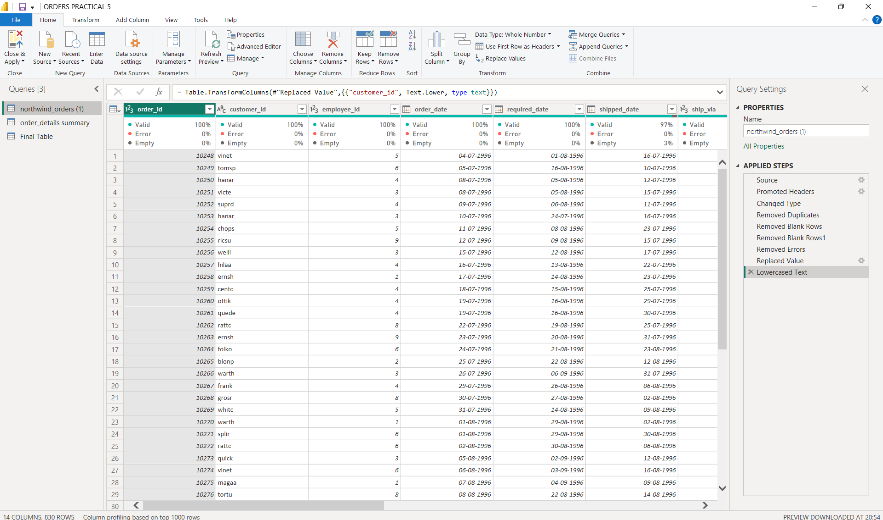
Step 1: Loading Data in Power BI Desktop: Import both the Orders and Order Details datasets into Power BI using the Get Data option. Once loaded, check the model view for relationships between the tables. If no relationship exists, create a relationship using OrderID as the key to connect the tables. However, Power BI will automatically detect the relationship, this relationship ensures that both datasets could be analysed together seamlessly.
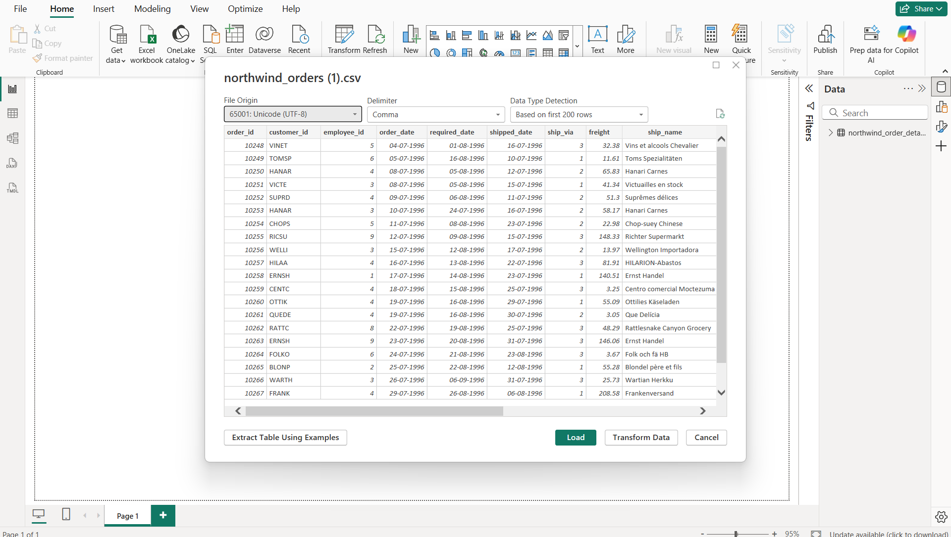
Step 3: Data Modelling: In Power BI’s Model View, relationships were checked between the Orders and Order Details tables. Using OrderID as the key, a one-to-many relationship was created, linking single orders to multiple order details. This ensured accurate aggregation of sales, customer, and shipping information across tables for reliable analysis.
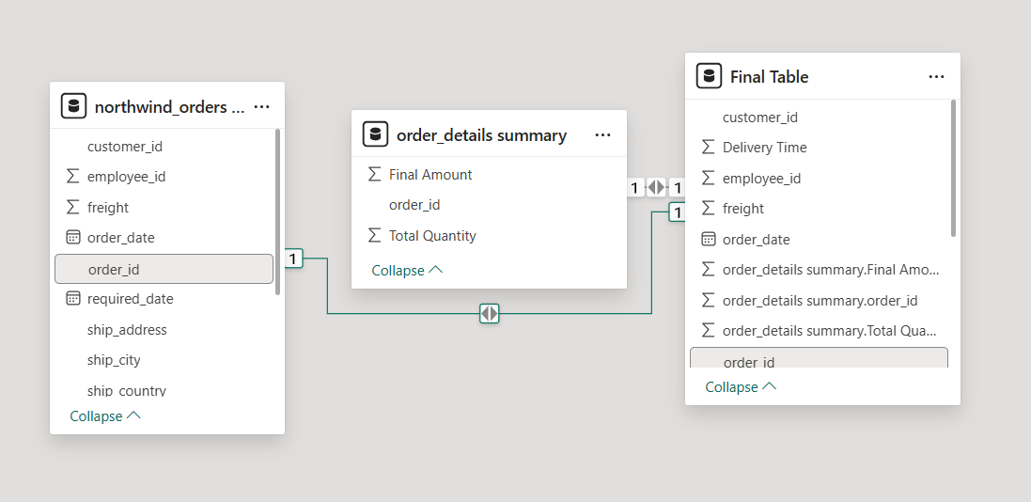

Step 2: Cleaning & Transforming Data: Once the datasets were imported, they were opened in Power Query Editor for cleaning and transformation. The first step was to remove unnecessary noise in the data. Any blank rows that did not contain meaningful values were deleted, as they could cause incorrect aggregations in reports. Similarly, duplicate rows were removed to ensure accuracy and consistency, since repeated entries would artificially inflate totals. Next, unwanted columns that were not required for analysis were dropped to make the dataset more efficient and focused.
To handle missing values, the ship_region column was examined. Several rows had blank entries, and instead of leaving them empty, they were replaced with the value “Not Known”. This step ensured that the data was more informative and prevented blanks from showing up in visualizations. The customer_id field was also standardized by converting all values to lowercase. This eliminated inconsistencies caused by mixed-case entries, ensuring smooth joins and grouping when creating reports.
In addition to cleaning, new calculated fields were created in the Order Details table to support meaningful analysis. A column named Total Amount was created by multiplying Unit Price with Quantity, giving the gross sales value for each product line. Another column named Final Amount was then calculated by applying the discount, using the formula Final Amount = Total Amount × (1 – Discount). This provided a more realistic measure of sales after accounting for reductions.
Finally, the two datasets were combined using the Merge Queries option. A new table named Final Table was created by merging the Orders and Order Details tables using OrderID as the common field. The merged table included all columns from the Orders dataset along with aggregated totals of Quantity and Final Amount for each order. This integration allowed for a complete, single view of each order, combining transactional and customer details in one place for deeper analysis.

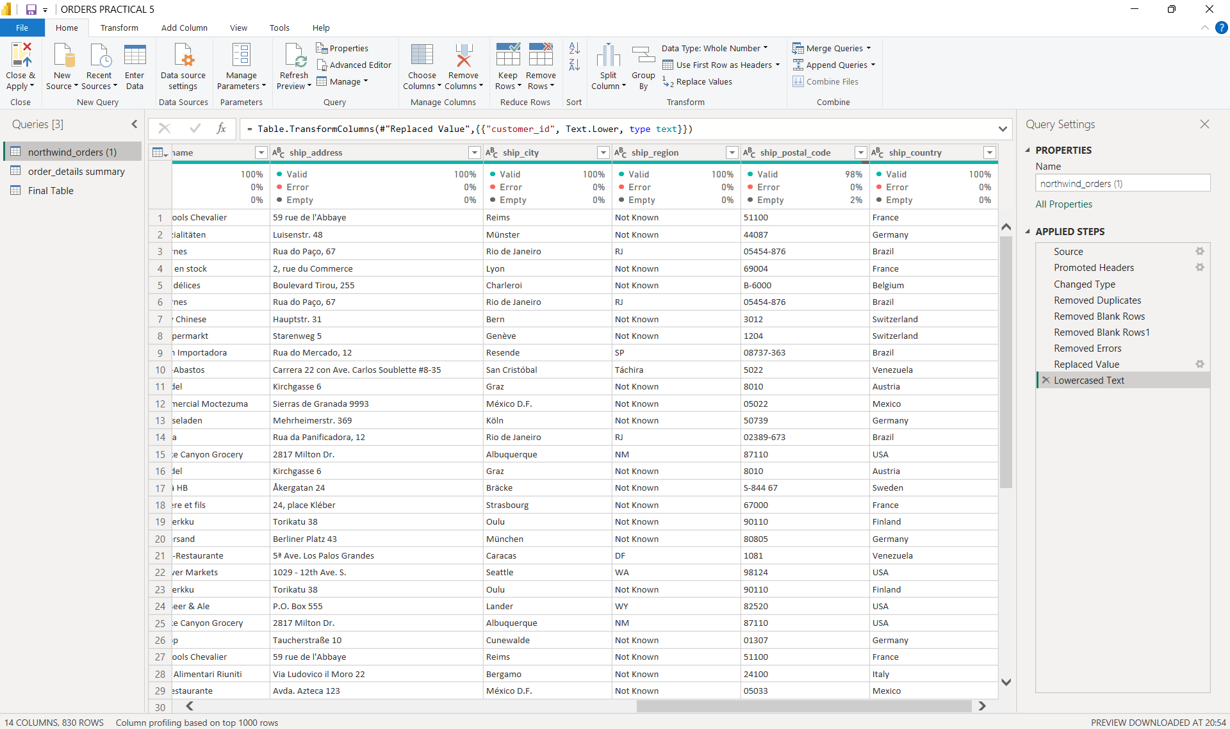

Step 3: Loading Cleaned Data Back & Building Visualizations: After all cleaning and transformation steps were completed, the prepared dataset was loaded back into Power BI Desktop for visualization.
The first visualization created was a Stacked Column chart showing the Top 5 Countries by Final Amount. This chart helped in identifying which countries contributed the highest revenue after discounts were applied, making it easier to focus on key markets. Next, a area chart of Average Freight by Shipping Method (Ship_via) was built. This visualization compared the average freight charges across different carriers or shipping methods, providing insights into which methods were more cost-effective for the business.
To study geographical sales trends, a line chart of Yearly Sales in Germany (Before Discount) was prepared. This chart displayed how sales in Germany changed over different years, helping analyse market growth and demand fluctuations in that specific country. Another important visualization was the Customer Orders by Country, shown using either a pie chart. This gave a clear picture of the customer base distribution across regions, highlighting countries with strong or weak customer engagement.
Finally, logistics performance was analysed by creating a Stacked column chart of the Top 5 Countries by Average Delivery Time. Delivery time was calculated as the difference between Order Date and Ship Date. Countries with longer delivery durations were highlighted, pointing out regions where the supply chain faced delays. This helped in identifying areas for improvement in shipping efficiency.
Together, these visualizations created a comprehensive dashboard, providing insights into revenue generation, freight management, yearly sales performance, customer distribution, and delivery challenges.

